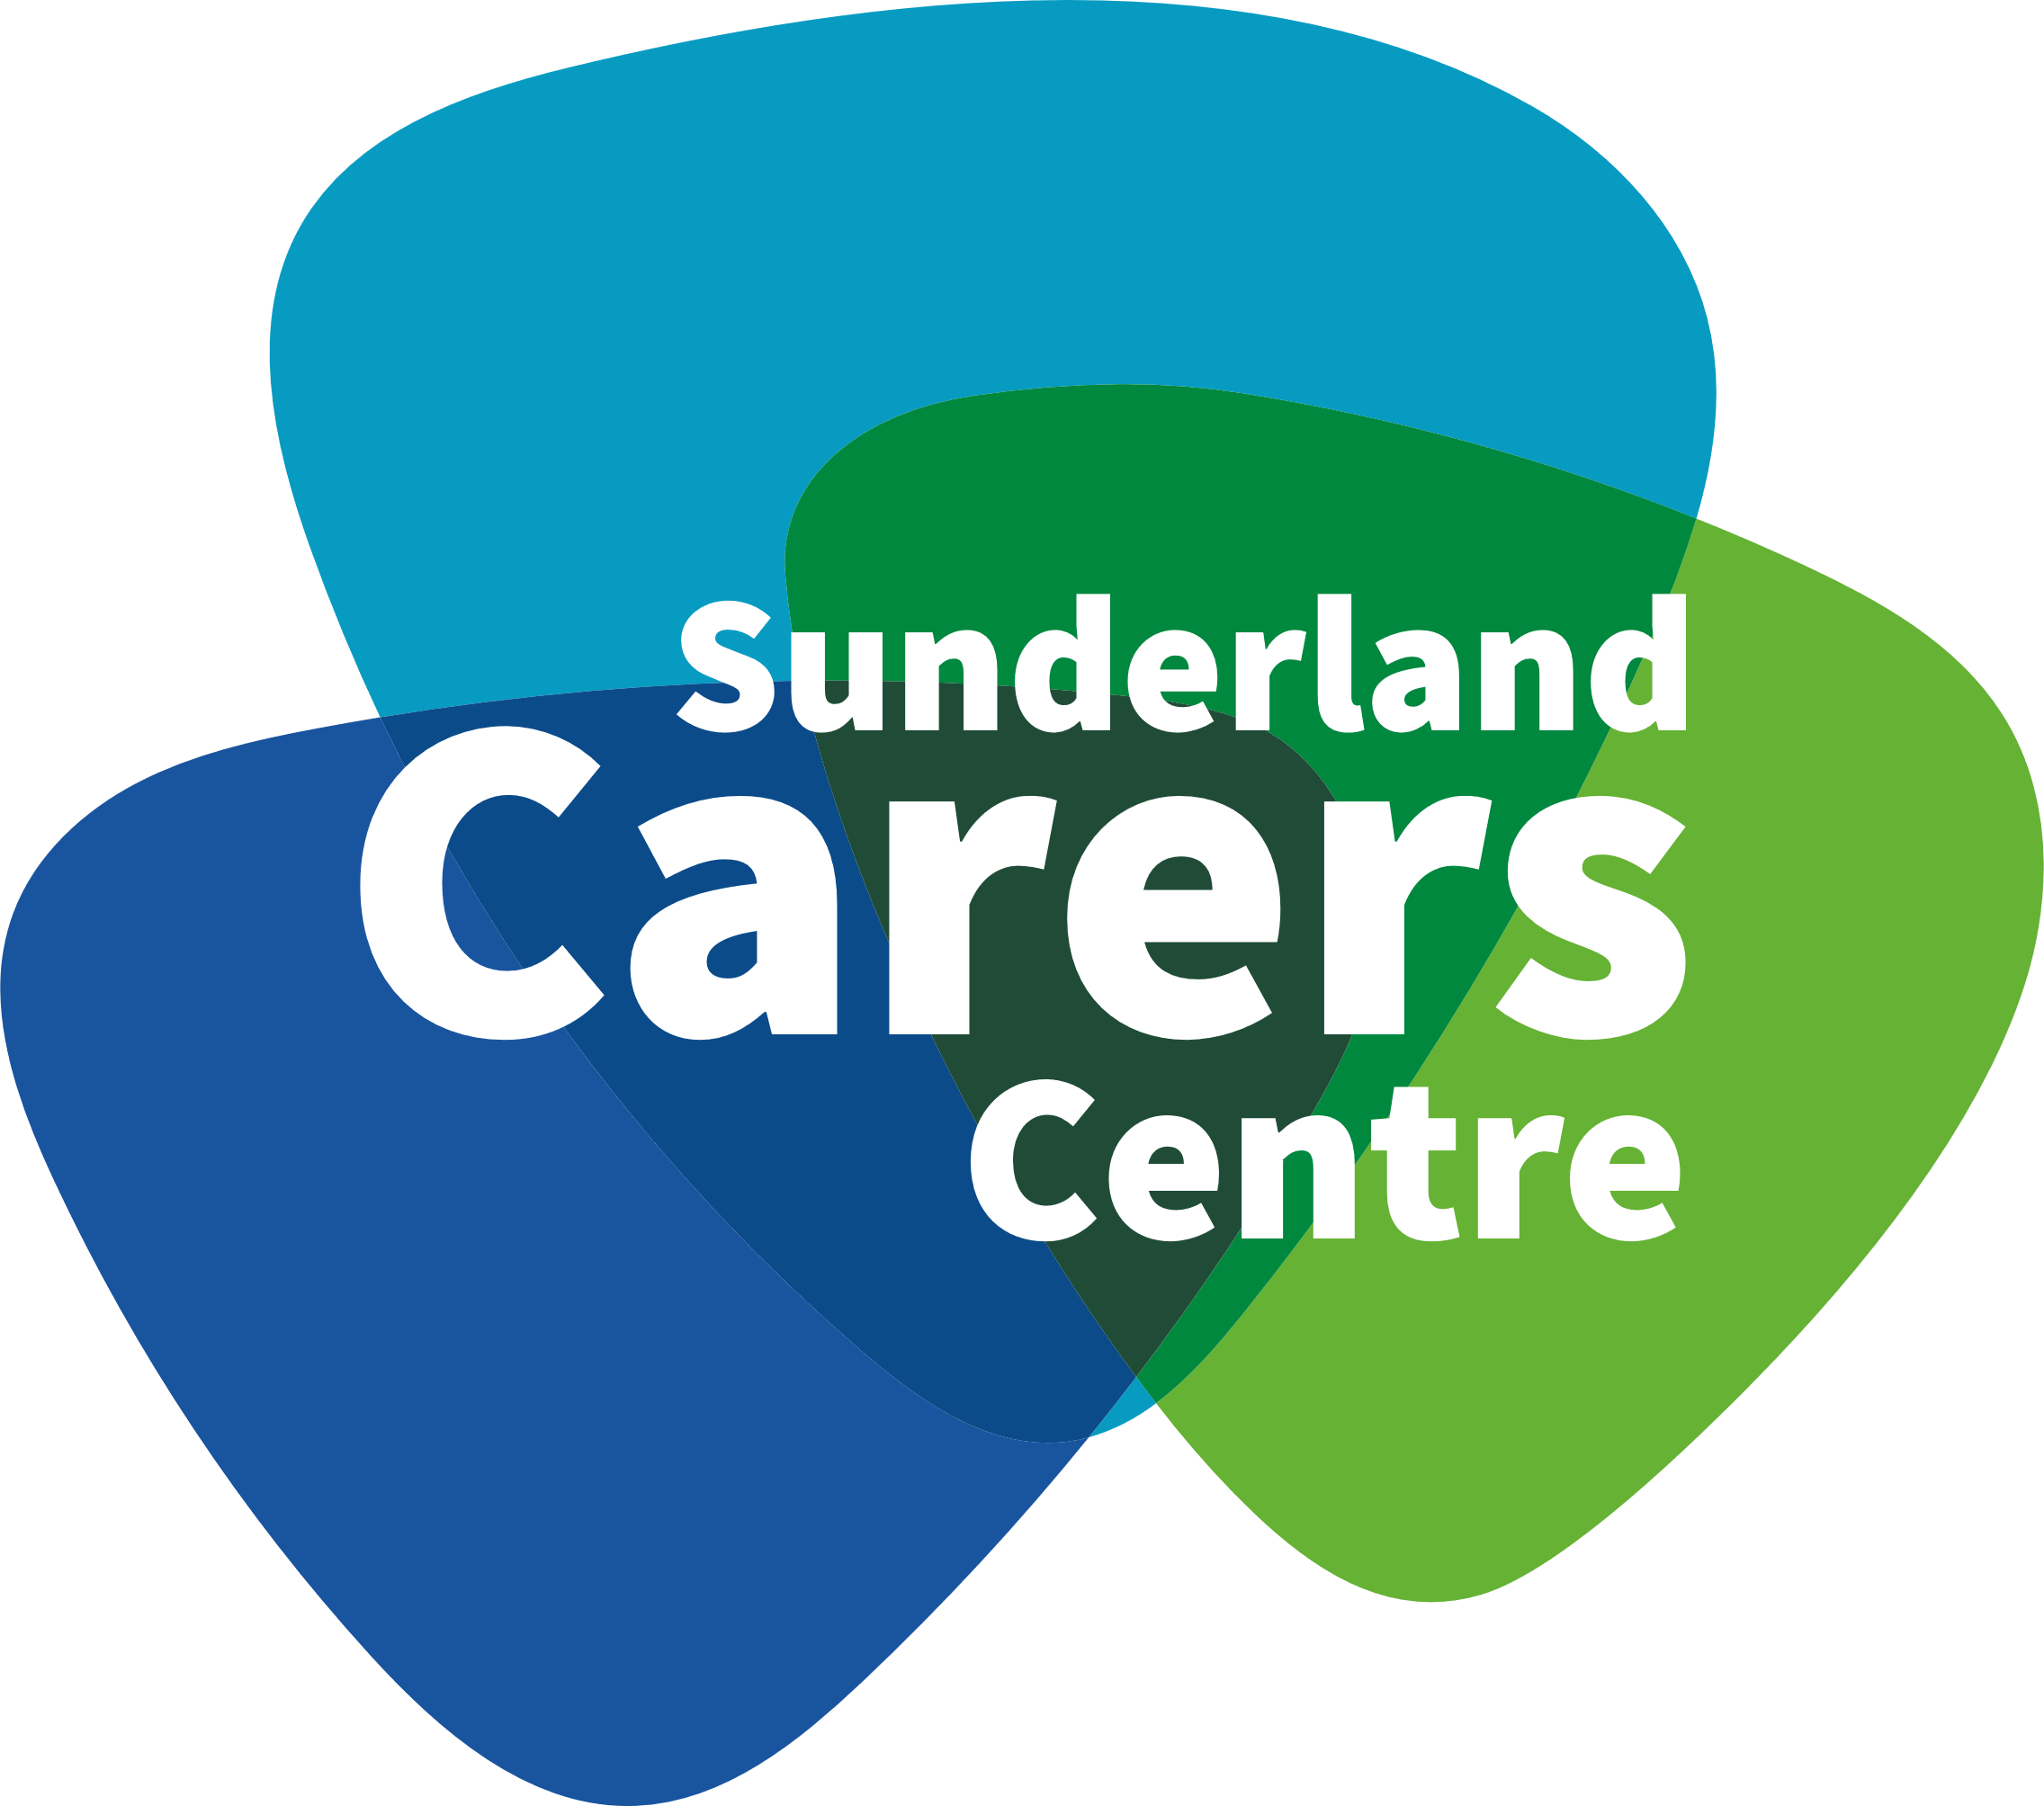

April 2022

Dear Sir/Madam,

Research Study: Barriers and facilitators to online engagement with support for carers

Sunderland Carers Centre, together with the University of Sunderland and the NIHR Applied Research Collaboration North East and North Cumbria, are carrying out a research study to explore carers views about accessing online support. This study is asking carers to complete a short survey about the types of support that they have accessed and to get their views about online support. The results of this study will help us to develop future support options for carers and to make these as accessible as possible.

You have been invited to consider taking part in this study because you are registered with Sunderland Carers Centre as a carer. Taking part in this study is voluntary. You do not have to take part if you do not want to. Survey responses will be collected anonymously, and all information collected will be handled confidentially.

Included with this letter is a Participant Information Leaflet. This leaflet explains more about the study and what is involved should you wish to take part. Please take the time to read this leaflet and if you would like more information before you make your mind up, or if you have any questions about the study, please contact:
- Nick Ainslie at Nick@sunderlandcarers.co.uk or 0191 5493768
- Dr Heather Yemm at heather.yemm@sunderland.ac.uk

A copy of the survey is also included, and you are invited to complete this if you are happy to do so. You can complete a paper copy of the survey or complete this online by following the weblink provided on the information leaflet.

Following the survey, some people will be invited to take part in an interview to discuss online support further. If you would like to find out more about this, please complete the enclosed contact details form (on the back page of the survey booklet) and return this.

Agreeing to find out more about the research does not mean that you have to take part. You can choose not to take part at any point, and this will not affect any care and support that you receive now or in the future.

Thank you for taking the time to read this letter.

Yours sincerely,

Nick Ainslie & Dr Heather Yemm
Project Leads

